**Trigorrilla TMC 2208 UART Mode**

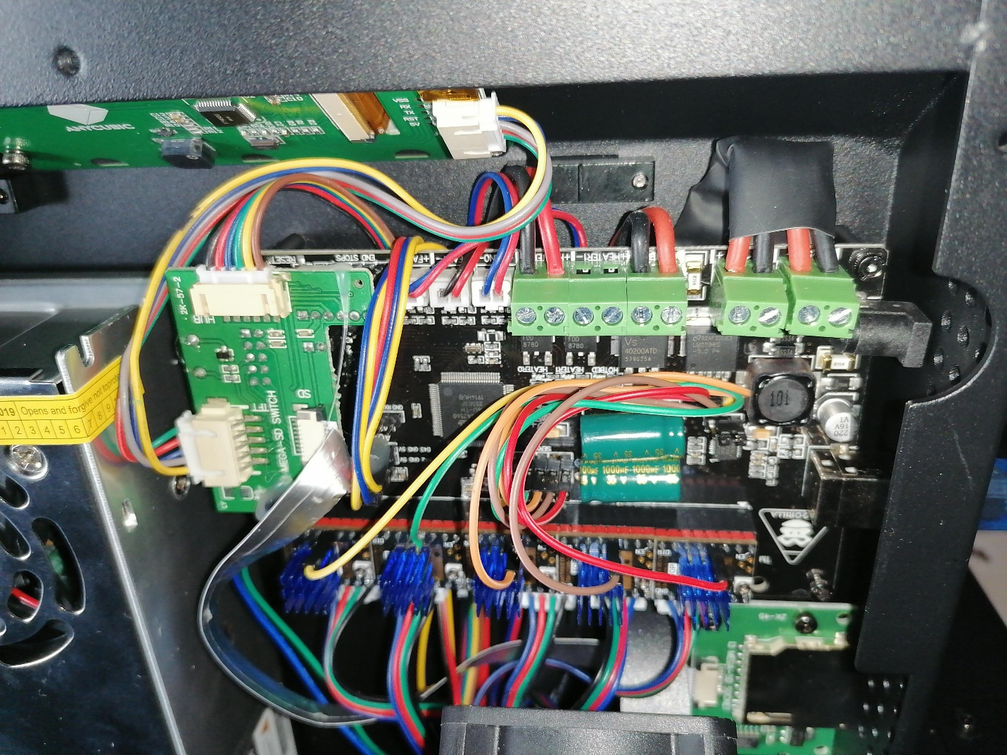

I banged my head against Google and Arduino IDE all day, but I finally figured it out. My problem was that I was trying to use a conspicuously marked hardware UART3 port which apparently was already taken by the TFT screen driver on a different data bus, so that didn't work at all. But I found that people had success with enabling a single driver in UART mode off of servo pin; they're all connected but not populated so I soldered a bunch of headers and attached my drivers to them, and configured all of these servo ports (D4 D5 D6 D11 D12) as *_SERIAL_TX_PIN outputs. I obviously have no feedback data from the drivers because there's not a single RX pin (it's possible to use exactly 1 w/ SD support or all 5 w/o SD support) but all configuration data passes to them and they work properly. My main goal was to enable SpreadCycle (because StealthChop can't drive the motors very fast and on a 12V PSU it's really a problem), but not having to physically screw around with vref pots sure is a nice bonus!

Here's the pin config I've pasted in pins_TRIGORILLA_14.h, on board version 1.0 it pin order exactly matches the driver order, in version 1.1 there's a different servo pinout but you can simply swap the wires as appropriate:

#if HAS_DRIVER(TMC2208)

#define X_SERIAL_TX_PIN 4

#define X_SERIAL_RX_PIN -1

#define Y_SERIAL_TX_PIN 5

#define Y_SERIAL_RX_PIN -1

#define Z_SERIAL_TX_PIN 12

#define Z_SERIAL_RX_PIN -1

#define Z2_SERIAL_TX_PIN 6

#define Z2_SERIAL_RX_PIN -1

#define E0_SERIAL_TX_PIN 11

#define E0_SERIAL_RX_PIN -1

#endif

**TMC 2208 Standalone mode**

1. Remove the old stepper drivers
2. Install the new ones.
3. Short the following pins: TX and RX ([picture](https://imgur.com/gallery/EmrUyWN))
4. Unplug the cables and plug them into the socket they were in but in a mirrored position. (If you don't do this, the motors will move in the wrong direction.) ([picture](http://imgur.com/gallery/iJJA8HF))
5. Adjust the reference voltage to about 0.9V-1V. (You can measure it across the screw of the potentiometer and ground.)

**Trigorilla Default Config**

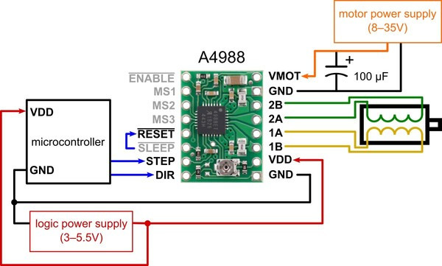

|  |  |  |  |
| --- | --- | --- | --- |
| **MS1** | **MS2** | **MS3** | **Microstep Resolution** |
| Low | Low | Low | Full step |
| High | Low | Low | Half step |
| Low | High | Low | Quarter step |
| High | High | Low | Eighth step |
| High | High | High | Sixteenth step |

RST, SLP, and EN. For details about these power states, see the datasheet. Please note that the RST pin is floating; if you are not using the pin, you can connect it to the adjacent SLP pin on the PCB to bring it high and enable the board.